Lithovolt – Mobile App Developer Documentation
1. Executive Summary
Lithovolt is a mobile application designed to streamline battery warranty management and wholesaler onboarding. The app allows users to generate digital warranty certificates and enables wholesalers to register and purchase batteries\other products at wholesale price.

2. App Purpose
- Generate Warranty Certificates – Customers and partners can create, store, and access warranty certificates for purchased batteries.
- Wholesaler Registration – Businesses can register as verified Lithovolt wholesalers.

3. Key Features
A. Warranty Certificate Module
- Create a new warranty certificate
- Input product details (make, model, year, Registration no, purchase date)
- Input customer details (name, phone, email)
- Auto-generate certificate ID
- Download / View / Share certificate as PDF or digital card
- Store and list certificates under user\admin profile
B. Wholesaler Registration Module
- Wholesaler signup form (business\individual name, ABN/registration no., address, contact)
- Upload business documents (optional/required)
- Verification workflow (admin approval)
- Wholesaler dashboard (after approval)

Screen-by-Screen Explanation

1. Splash Screen
- Displays Lithovolt logo
- Auto-check login state
- 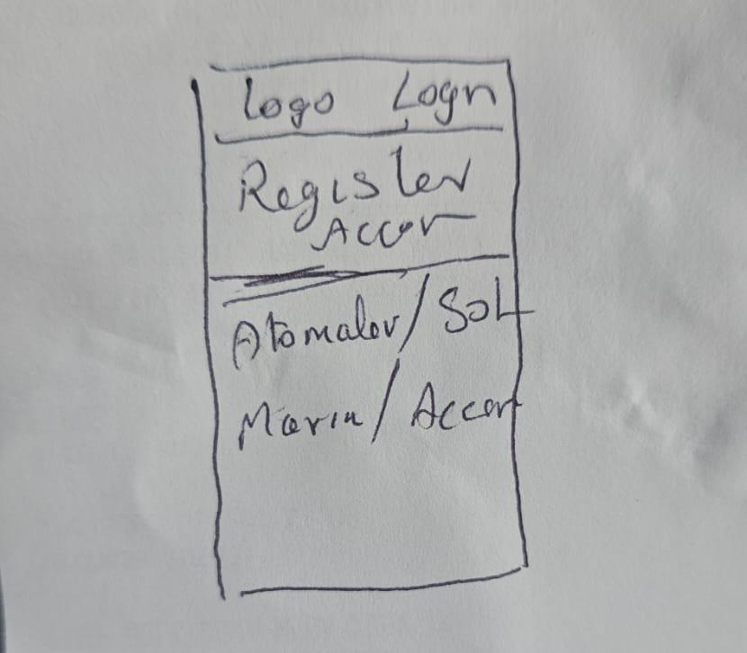
- Register for an account
- Automotive battery\Solar battery\Marine\Accessories (4 buttons for different category)

2. Login Screen
- Inputs: Email / Phone + Password
- Buttons: Login, Forgot Password, Signup
- Error handling for invalid credentials

4. Dashboard (Customer)
- Options:
  - Create Warranty Certificate
  - View Warranty Certificates
  - Register as Wholesaler

Create Warranty Certificate Screen
- Sections:
  - Product Details: Battery model, serial number, purchase date
  - Customer Details: Name, phone, email
- Button: Generate Certificate
- Validation for required fields
- Navigation: → Certificate Preview

5. User Flows
A. Warranty Certificate Flow
- User logs in → dashboard
- Select "Create Warranty Certificate"
- Enter product + customer details
- Submit → certificate generated
- Preview / Save / Download / Share
B. Wholesaler Registration Flow
- User selects "Register as Wholesaler"
- Fill form → upload documents
- Submit → success message
- Admin reviews and approves
- Wholesaler gets access to panel

6. Admin Dashboard
- Customer profile
- Customer warranty certificate
- Add or Delete products

- Add or Delete Sellers
- Inventry
- Order management

7. Deliverables Expected from Developer
- Full mobile app (Android / iOS)
- API integration
- Admin panel
- Testing + debugging
- Deployment to Play Store/App Store

End of Documentation

